Chapter 10: Training and Testing ML Models

Answer Key
1. Conceptual Questions
1. Underfitting vs Overfitting
Underfitting
- Model too simple to capture patterns
- High training error
- High validation error
Overfitting
- Model memorizes training data
- Very low training error
- High validation error

2. Training 99%, Validation 65%
This indicates overfitting.
Reason:
- Model fits training data extremely well.
- But fails to generalize to unseen data.

3. Techniques to Reduce Overfitting
Examples:
- Regularization (L1 / L2)
- Cross-validation
- Reduce model complexity
- More training data
- Dropout (in neural networks)
- Early stopping

4. Precision vs Recall
Precision important when:
- False positives are costly
Example: spam filter wrongly blocking legitimate emails.
Recall important when:
- Missing positives is dangerous
Example: disease detection.

2. Confusion Matrix Calculations
Confusion matrix:
 | Pred Pos | Pred Neg
Actual Pos | 70 | 30
Actual Neg | 20 | 80
Values:
- TP = 70
- FN = 30
- FP = 20
- TN = 80

1. True Positive Rate (Recall)
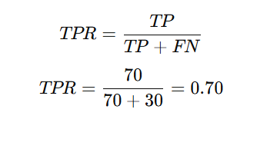
TPR = 0.70

2. False Positive Rate
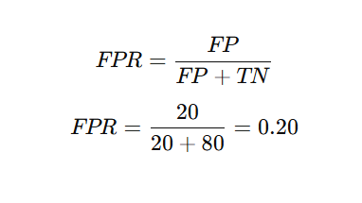
FPR = 0.20

3. Precision
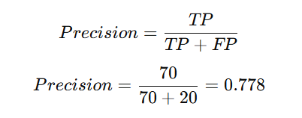
Precision ≈ 0.78

4. Recall
Recall = TPR
Recall = 0.70

Interpretation
The model detects 70% of positives and makes 20% false alarms among negatives.

3. Metric Comparison
Model | Precision | Recall
A | 0.90 | 0.50
B | 0.65 | 0.85

1. Fraud Detection
Better model: Model B
Reason:
- Missing fraud is costly.
- High recall preferred.

2. Spam Filtering
Better model: Model A
Reason:
- Avoid false positives (blocking good emails).
- High precision preferred.

3. F1 Score
Formula

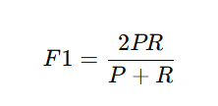
Model A
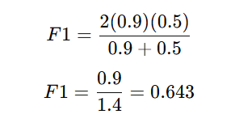

F1 ≈ 0.64

Model B
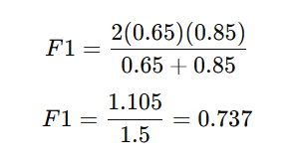

F1 ≈ 0.74

4. Threshold Selection
Data:
Instance | True | Prob
1 | 1 | 0.92
2 | 1 | 0.81
3 | 1 | 0.63
4 | 0 | 0.55
5 | 0 | 0.40
6 | 0 | 0.25

Threshold = 0.5
Predicted positive: 1,2,3,4
Confusion matrix:
 | Pred Pos | Pred Neg
Actual Pos | 3 | 0
Actual Neg | 1 | 2
Values:
TP = 3
FN = 0
FP = 1
TN = 2

Precision
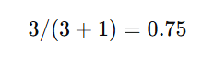
Recall
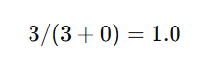

Threshold = 0.7
Predicted positive: 1,2
Confusion matrix:
 | Pred Pos | Pred Neg
Actual Pos | 2 | 1
Actual Neg | 0 | 3
Values:
TP = 2
FN = 1
FP = 0
TN = 3

Precision
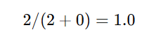
Recall
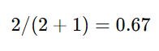

Effect of Increasing Threshold
Increasing threshold:
- Precision increases
- Recall decreases
- TPR decreases
- FPR decreases

5. ROC Curve
Points:
FPR | TPR
0.05 | 0.30
0.10 | 0.55
0.25 | 0.75
0.50 | 0.90
Plotting these produces the ROC curve.

Best Threshold
Usually around 0.7
Reason:
- Good balance between TPR and FPR.

ROC AUC Meaning
ROC AUC measures the probability that:
the classifier ranks a random positive example higher than a random negative example.
Interpretation:
AUC | Meaning
0.5 | random guessing
0.7–0.8 | acceptable
0.8–0.9 | good
0.9+ | excellent

6. Model Diagnosis
Model 1:
Training = 95%
Validation = 93%
Good generalization.

Model 2:
Training = 95%
Validation = 60%
Large gap → overfitting.

Possible improvements:
- regularization
- cross-validation
- simpler model
- more data
- feature selection

7. Medical Screening Example
Confusion matrix:
 | Pred Disease | Pred Healthy
Actual Disease | 180 | 20
Actual Healthy | 120 | 680
Values:
TP = 180
FN = 20
FP = 120
TN = 680

Precision
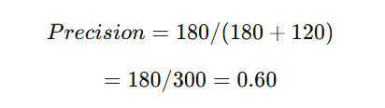

Recall
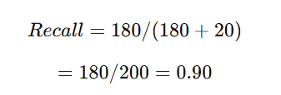

TPR
Same as recall:
0.90

FPR
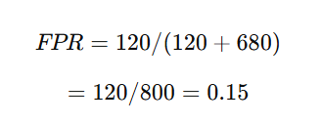

Threshold Decision
For medical screening:
Decrease threshold
Reason:
- Prefer catching more disease cases.
- False negatives are dangerous.

Healthcare Trade-off
False Positive
- extra tests
- anxiety
- cost
False Negative
- missed diagnosis
- disease progression
- potentially fatal
Therefore high recall is prioritized.

